ANALYSIS AND PREDICTION OF HOSPITAL READMISSION RATES USING MACHINE LEARNING

Final Project Report

Course: Healthcare Analytics
Instructor: A. Sodiq Shofoluwe
Institution: ST. CLAIR COLLEGE
Submitted By:
Om Patel
Krupa Patel
Vishal Sharma

Introduction
Hospital readmissions are widely recognized as a critical indicator of healthcare quality, operational efficiency, and patient outcomes. A hospital readmission occurs when a patient is admitted to a hospital within a short period after being discharged, often within 30 days. High readmission rates are generally associated with issues such as inadequate treatment, premature discharge, poor coordination of care, or insufficient follow-up procedures.
From a healthcare management perspective, reducing readmissions is a priority because it improves patient well-being and reduces unnecessary healthcare costs. Governments and healthcare organizations, including the Centers for Medicare & Medicaid Services (CMS), actively monitor readmission rates and impose penalties on hospitals with excessive readmissions. Therefore, analyzing readmission data is essential for identifying inefficiencies and improving healthcare delivery systems.
This project focuses on analyzing hospital readmission data obtained from CMS. The primary objective is to identify patterns and variations in readmission rates across different states, medical conditions, and hospital characteristics. The analysis also aims to evaluate whether certain factors, such as hospital size or discharge volume, influence readmission outcomes.
To achieve these goals, this study integrates multiple analytical techniques, including data preprocessing, exploratory data analysis (EDA), statistical hypothesis testing, and machine learning modeling. Statistical methods are used to validate observed patterns, while machine learning models are applied to explore predictive relationships within the dataset.
By combining these approaches, the project provides a comprehensive understanding of hospital readmission behavior and contributes to the broader field of healthcare analytics.

Related Work
Healthcare analytics has been widely used to study hospital readmissions, patient outcomes, and healthcare system performance. Numerous studies have highlighted that readmission rates are influenced by a combination of clinical, operational, and demographic factors.
Previous research indicates that hospital characteristics such as size, staffing levels, and available resources play a significant role in determining readmission rates. Larger hospitals may handle more complex cases, which can lead to higher readmission risks, while smaller hospitals may lack sufficient infrastructure for comprehensive patient care.
Patient-related factors, including age, underlying medical conditions, and socioeconomic status, have also been identified as key contributors to readmissions. For instance, patients with chronic illnesses or limited access to follow-up care are more likely to be readmitted.
The CMS dataset used in this project provides standardized performance metrics, including the Excess Readmission Ratio. This metric adjusts for expected readmissions based on patient and hospital characteristics, allowing fair comparisons across hospitals.
In terms of methodology, regression models have traditionally been used to analyze relationships between variables and predict readmission outcomes. More recently, machine learning techniques such as Decision Trees, Random Forest, and Gradient Boosting have gained popularity due to their ability to capture complex, non-linear relationships.
Several studies have demonstrated that ensemble models often outperform simpler models in predictive tasks. However, simpler models like Linear Regression remain valuable due to their interpretability and ease of implementation.
This project builds upon existing research by combining statistical testing with multiple machine learning models. The goal is not only to predict readmission rates but also to provide interpretable insights into the factors influencing these outcomes.

Methods

Dataset Description
The dataset used in this study was obtained from the Centers for Medicare & Medicaid Services (CMS). It contains hospital-level data related to readmission reduction programs across the United States.
The dataset includes several important variables:
- State: Represents the geographic location of each hospital
- Measure Name: Indicates the medical condition associated with readmission measurement
- Number of Discharges: Represents the total number of patients discharged from a hospital
- Excess Readmission Ratio: A standardized metric used to evaluate hospital performance
The Excess Readmission Ratio is defined as:
Excess Readmission Ratio = Predicted Readmissions / Expected Readmissions
A value greater than 1 indicates higher-than-expected readmissions, while a value less than 1 indicates better performance.

Data Cleaning
Before analysis, the dataset required extensive preprocessing to ensure accuracy and reliability.
First, irrelevant columns such as hospital addresses, phone numbers, and identification codes were removed. These variables did not contribute to the analysis and would unnecessarily increase complexity.
Next, missing values were handled. The dataset contained entries labeled as “Not Available,” which were replaced with null values. Numeric columns such as Excess Readmission Ratio and Number of Discharges were converted into appropriate numeric formats to allow computation.
Rows containing missing values were removed using appropriate filtering techniques. Although this reduced the dataset size slightly, it ensured that all remaining records were complete and reliable.
Duplicate records were also identified and removed to prevent bias in the analysis.
Outlier detection was performed using the Interquartile Range (IQR) method. The first quartile (Q1) and third quartile (Q3) were calculated, and the IQR was defined as the difference between Q3 and Q1. Values outside the acceptable range were considered outliers and removed.
This preprocessing step was crucial for improving data quality and ensuring that subsequent analyses were not affected by noise or extreme values.

Exploratory Data Analysis (EDA)
Exploratory Data Analysis was conducted to gain insights into the dataset and identify patterns.
Exploratory Data Analysis (EDA) was conducted to systematically examine the structure, distribution, and relationships within the dataset, with the objective of uncovering meaningful patterns and guiding subsequent statistical and machine learning analyses.
The distribution of the Excess Readmission Ratio indicates that the majority of hospitals cluster around the benchmark value of 1.0. This suggests that, for most institutions, observed readmissions are closely aligned with expected levels after risk adjustment. The relatively tight concentration around this value reflects overall stability in hospital performance, while the presence of slight skewness and extreme values highlights the existence of outliers and performance variability across institutions.
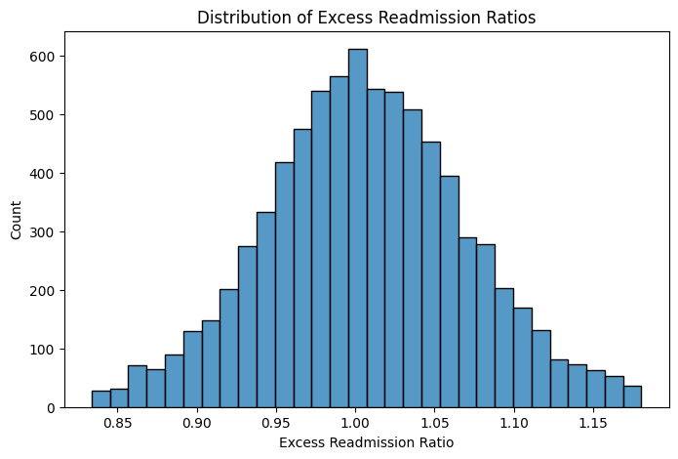
A state-level aggregation reveals substantial geographic variation in readmission rates. Certain states consistently exhibit higher average readmission ratios, indicating potential systemic inefficiencies, differences in healthcare infrastructure, or variations in patient populations. Conversely, states with lower ratios demonstrate comparatively better performance, potentially reflecting more effective care coordination and discharge planning strategies.
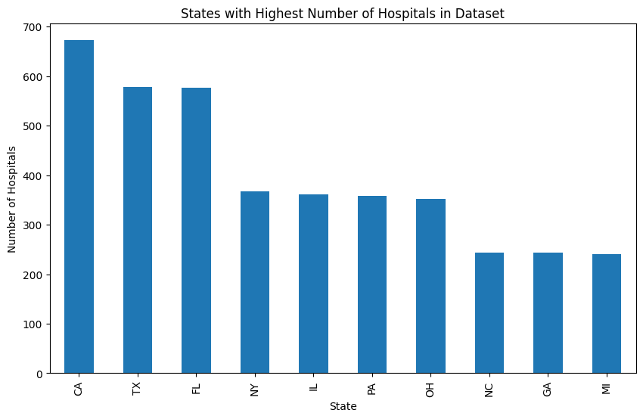
To further investigate regional disparities, the top and bottom performing states were identified based on average readmission ratios. This comparative analysis highlights a clear performance gap between regions, emphasizing the importance of localized healthcare policies and resource allocation in influencing patient outcomes.

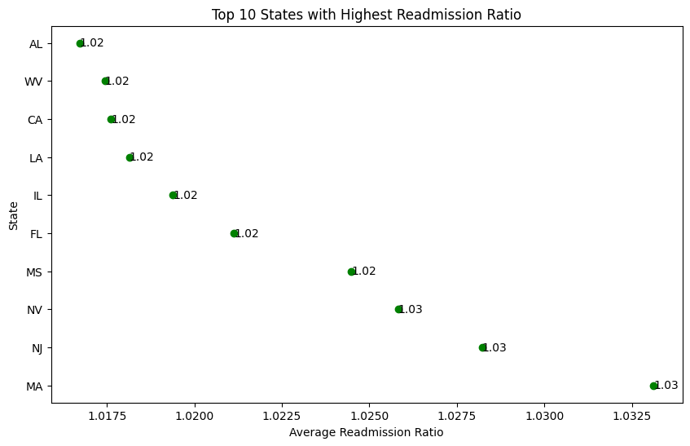
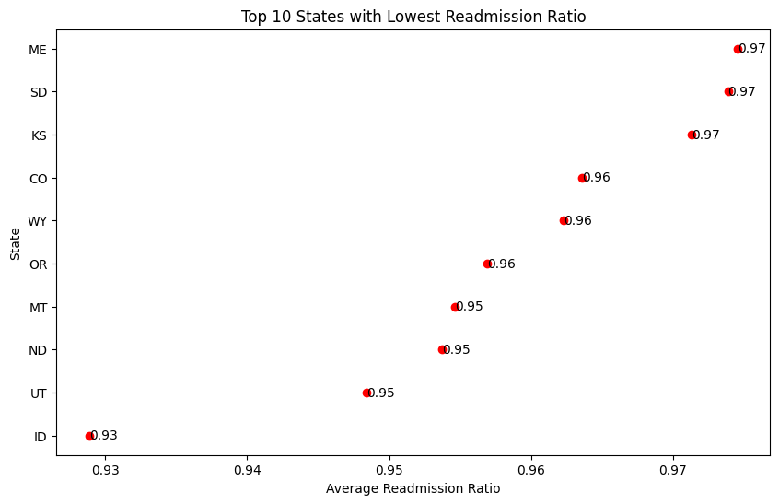

In addition to geographic analysis, condition-based exploration was conducted to assess how readmission rates vary across different medical conditions. The results indicate that certain conditions are associated with consistently higher readmission ratios, suggesting that disease complexity, treatment challenges, and post-discharge care requirements play a significant role in readmission risk.

Furthermore, the relationship between hospital size, measured by the number of discharges, and readmission ratio was examined using scatter plot analysis. The observed pattern suggests a weak and non-linear association, indicating that hospital size alone is not a strong predictor of readmission performance. This finding implies that other latent factors, such as quality of care, patient management practices, and socioeconomic conditions, may have a more substantial impact.
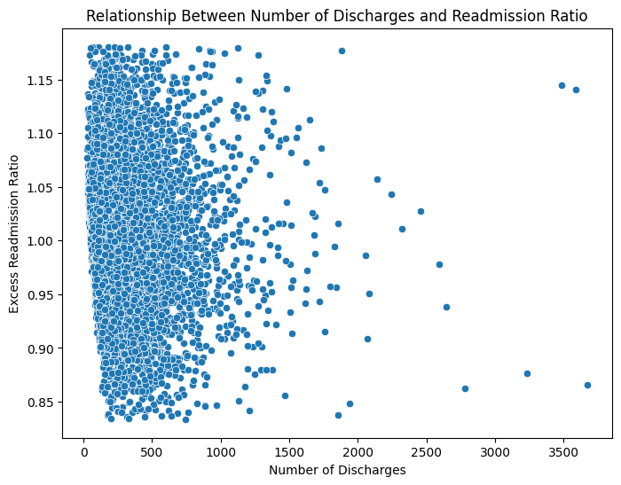
Overall, the EDA highlights that while hospital readmission ratios are generally stable around expected values, significant variability exists across states, conditions, and institutions. These insights provide a strong foundation for subsequent hypothesis testing and predictive modeling.

Hypothesis Testing
Statistical tests were conducted to validate key findings:
- Correlation Analysis: A Pearson correlation test revealed a weak but statistically significant relationship between hospital size and readmission rates.
- Independent T-Test: A significant difference was observed between small and large hospitals.
- One-Sample T-Test: The average readmission ratio was found to significantly differ from the benchmark value of 1.0.
- Variability Analysis: Standard deviation and variance indicated relatively low variability in readmission ratios.
- Outlier Impact Analysis: Removing outliers resulted in slight improvements in model performance.

Machine Learning Models
To analyze and predict the Excess Readmission Ratio, multiple machine learning models were implemented using a structured modeling pipeline. The objective was to compare the performance of linear and non-linear algorithms and evaluate their ability to capture relationships within the dataset.
Modeling Procedure
The modeling process began with the selection of relevant numerical features from the dataset. The target variable was defined as the Excess Readmission Ratio, while all other numerical variables were used as input features.
The dataset was then divided into training and testing subsets using an 80:20 split. This ensured that models were trained on one portion of the data and evaluated on unseen data to assess generalization performance.
To improve model stability and ensure fair comparison across algorithms, feature scaling was applied using the StandardScaler technique. This step normalized the data by transforming features to have zero mean and unit variance.
Several machine learning models were implemented:
- Linear Regression: Linear Regression was implemented as a baseline model due to its simplicity and interpretability. The model assumes a linear relationship between input features and the target variable.
After training on the scaled dataset, the model was evaluated using the test data. It demonstrated consistent performance and provided a reliable benchmark for comparison. The relatively strong performance of Linear Regression suggests that the underlying relationships in the dataset are primarily linear in nature.
- Decision Tree: A Decision Tree Regressor was implemented to capture non-linear relationships within the dataset. Unlike Linear Regression, this model splits the data into multiple branches based on feature values, allowing it to model complex patterns.
The model was trained using the same training dataset and evaluated on the test set. While it was able to capture certain non-linear trends, it showed signs of overfitting and did not generalize as well as the baseline model.
- Random Forest: Random Forest, an ensemble learning method, was applied to improve prediction accuracy and reduce overfitting. This model constructs multiple decision trees and aggregates their predictions to produce a more robust output.
The Random Forest model was trained using the same dataset and parameters. Although it reduced overfitting compared to a single decision tree, its performance improvement was limited. This indicates that increasing model complexity did not significantly enhance predictive capability for this dataset.
- Gradient Boosting: Gradient Boosting was implemented as an advanced ensemble technique that builds models sequentially, where each new model attempts to correct the errors of the previous one.
The model demonstrated competitive performance; however, similar to Random Forest, it did not significantly outperform Linear Regression. This suggests that the dataset does not exhibit strong non-linear patterns that require complex boosting techniques.

Model Evaluation
Models were evaluated using the following metrics:
- R² Score: Measures the proportion of variance explained by the model
- Mean Squared Error (MSE): Measures prediction error
These metrics provided a quantitative basis for comparing models.

Results
This section presents the quantitative findings obtained from statistical analysis and machine learning models. The results are reported using numerical metrics, tables, and visual summaries without interpretation.

1. Distribution of Readmission Ratios
The distribution of the Excess Readmission Ratio across hospitals is shown in Figure 1. The majority of hospitals cluster around the benchmark value of 1.0.
- Mean = 1.0018
- Median = 0.9973
- Standard Deviation = 0.0821

2. State-Level Variation
Average readmission ratios were computed for each state, revealing variation across regions.
Top 5 States (Highest Readmission Ratios):
State | Avg Ratio
MA | 1.0331
NJ | 1.0282
NV | 1.0258
MS | 1.0245
FL | 1.0211

3. Condition-Based Analysis
Readmission ratios were analyzed across different medical conditions.
Condition | Avg Ratio
CABG | 1.0171
COPD | 1.0104
AMI | 1.0101
Hip/Knee | 1.0073
Pneumonia | 1.0056
Heart Failure | 1.0033

4. Relationship Between Hospital Size and Readmission
A Pearson correlation analysis was conducted between Number of Discharges and Excess Readmission Ratio.
- Correlation coefficient (r) = -0.0815
- p-value = 5.78 × 10⁻¹³
(See Figure 3 for scatter plot.)

5. Hypothesis Testing Results
- Correlation Test
  - r = -0.0815
  - p-value = 5.78 × 10⁻¹³
- Variance and Spread
  - Variance ≈ 0.0067
  - Standard Deviation = 0.0821

6. Machine Learning Model Performance
The performance of different models was evaluated using R² and Mean Squared Error (MSE).
Model | R² Score | MSE
Linear Regression | 0.0311 | 0.00396
Decision Tree | 0.0472 | —
Random Forest | -0.0758 | —
Gradient Boosting | 0.0777 | —

7. Effect of Outlier Removal
Scenario | R² Score
Before Outliers | 0.0066
After Outliers | 0.0073

Discussion
The results of this study provide important insights into hospital readmission patterns, although the overall strength of relationships observed in the data is relatively modest.
The distribution of the Excess Readmission Ratio shows that most hospitals operate very close to the benchmark value of 1.0, with a mean of 1.0018 and a low standard deviation of 0.0821. This indicates that, after risk adjustment, hospital performance is generally consistent across the dataset. However, the presence of variability, even if limited, suggests that some hospitals systematically perform better or worse than expected.
Geographic analysis revealed noticeable differences in readmission rates across states. For example, states such as Massachusetts (1.0331) and New Jersey (1.0282) exhibited higher average readmission ratios, while other states performed closer to or below the national average. These differences may reflect variations in healthcare infrastructure, policy implementation, and access to post-discharge care. The results highlight the importance of regional factors in influencing healthcare outcomes.
Condition-based analysis further demonstrated that readmission rates vary across medical conditions. Procedures such as CABG (1.0171) and conditions like COPD (1.0104) and AMI (1.0101) showed relatively higher readmission ratios compared to others such as Heart Failure (1.0033). This suggests that clinical complexity and the nature of treatment play a role in readmission risk, although the differences remain relatively small in magnitude.
The relationship between hospital size and readmission rates was found to be weak but statistically significant (r = -0.0815, p < 0.001). The negative correlation indicates that hospitals with higher discharge volumes tend to have slightly lower readmission ratios. However, the magnitude of this relationship is very small, suggesting that hospital size alone is not a meaningful predictor of readmission performance. This reinforces the idea that qualitative factors such as care coordination, discharge planning, and patient follow-up are likely more influential.
The machine learning results further support this conclusion. All models demonstrated low predictive performance, with the best-performing model, Gradient Boosting, achieving an R² score of only 0.0777. Linear Regression (R² = 0.0311) and Decision Tree (R² = 0.0472) also showed limited explanatory power, while Random Forest performed poorly with a negative R² value (-0.0758), indicating that it failed to generalize effectively. These results suggest that the available features in the dataset are insufficient to accurately predict readmission outcomes.
Additionally, the removal of outliers resulted in only a marginal improvement in model performance (R² increasing from 0.0066 to 0.0073). This indicates that extreme values were not a major source of model error and that the primary limitation lies in the lack of strong predictive features rather than noise in the data.
Overall, the findings suggest that hospital readmissions are influenced by multiple factors, but the dataset used in this study does not capture enough of these variables to build highly accurate predictive models. Important factors such as patient demographics, comorbidities, socioeconomic status, and quality of post-discharge care are not included, which likely limits the explanatory power of both statistical and machine learning approaches.
These results are consistent with existing research, which indicates that hospital readmissions are complex and multifactorial. While this study successfully identifies general patterns and weak relationships, it also highlights the limitations of using aggregated hospital-level data for predictive modeling.

Conclusion
This project successfully analyzed hospital readmission patterns using both statistical and machine learning techniques. The study demonstrated that readmission rates vary across states, medical conditions, and hospital types.
While predictive performance was limited, the analysis provided valuable insights into healthcare trends and system behavior. Future work could focus on incorporating patient-level data and additional variables to improve prediction accuracy and model performance.

Contributions
This project was completed collaboratively, with each team member contributing to different stages of the data analysis, modeling, and report preparation.
Om Patel was primarily responsible for data preprocessing and preparation. This included handling missing values, converting data types, removing duplicates, and performing outlier detection using the IQR method. In addition, Om implemented the Linear Regression model, including data splitting, feature scaling, model training, and evaluation using R² score and Mean Squared Error.
Krupa Patel focused on exploratory data analysis and data visualization. This involved analyzing the distribution of the Excess Readmission Ratio, performing state-level comparisons, and identifying top and bottom performing states. Krupa also developed visualizations such as histograms, bar charts, and scatter plots, and implemented the Decision Tree model to explore non-linear relationships in the dataset.
Vishal Sharma contributed to the implementation of advanced machine learning models, including Random Forest and Gradient Boosting. This included model training, tuning, and evaluation. Vishal also conducted model comparisons and analyzed performance differences across models.
All team members collaboratively contributed to hypothesis testing, interpretation of results, and preparation of the final report. The team worked together to ensure consistency in analysis, proper documentation, and alignment with project requirements.

References
- Hospital Readmissions Reduction https://data.cms.gov/provider-data/dataset/9n3s-kdb3#data-table
- Centers for Medicare & Medicaid Services (CMS): https://data.cms.gov
- Centers for Disease Control and Prevention (CDC): https://www.cdc.gov

Appendices
#Average Readmission Ratio by State
state_readmission = df.groupby('State')['Excess Readmission Ratio'].mean().sort_values(ascending=False)

print(state_readmission.head(10))
#Readmission Ratio by Measure
measure_readmission = df.groupby('Measure Name')['Excess Readmission Ratio'].mean().sort_values(ascending=False)

print(measure_readmission)

#Readmission by Medical Condition
plt.figure(figsize=(10,6))
measure_readmission.plot(kind='bar')
plt.title("Average Readmission Ratio by Medical Condition")
plt.xlabel("Measure Name")
plt.ylabel("Average Readmission Ratio")
plt.xticks(rotation=45)
plt.show()

#Distribution of Readmission Ratios
plt.figure(figsize=(8,5))
sns.histplot(df['Excess Readmission Ratio'], bins=30)
plt.title("Distribution of Excess Readmission Ratios")
plt.show()

# Top 10 States with Lowest Readmission Ratio

lowest_states = state_readmission.sort_values(ascending=True).head(10)

plt.figure(figsize=(10,6))
plt.scatter(lowest_states.values, lowest_states.index, color='red')

for i, value in enumerate(lowest_states.values):
plt.text(value, i, f"{value:.2f}", va='center')

plt.title("Top 10 States with Lowest Readmission Ratio")
plt.xlabel("Average Readmission Ratio")
plt.ylabel("State")

plt.show()

#Top 10 States with highest Readmission Ratio

highest_states = state_readmission.sort_values(ascending=False).head(10)

plt.figure(figsize=(10,6))
plt.scatter(highest_states.values, highest_states.index, color='green')

for i, value in enumerate(highest_states.values):
plt.text(value, i, f"{value:.2f}", va='center')

plt.title("Top 10 States with Highest Readmission Ratio")
plt.xlabel("Average Readmission Ratio")
plt.ylabel("State")

plt.show()

#Number of Hospitals per State

state_counts = df['State'].value_counts()

plt.figure(figsize=(10,6))
state_counts.head(10).plot(kind='bar')
plt.title("States with Highest Number of Hospitals in Dataset")
plt.xlabel("State")
plt.ylabel("Number of Hospitals")
plt.show()

#Scatter Plot: Discharges vs Readmission Ratio
#This explores if patient volume affects readmission rates.

plt.figure(figsize=(8,6))
sns.scatterplot(x='Number of Discharges', y='Excess Readmission Ratio', data=df)
plt.title("Relationship Between Number of Discharges and Readmission Ratio")
plt.xlabel("Number of Discharges")
plt.ylabel("Excess Readmission Ratio")
plt.show()

#Boxplot by Medical Condition
#This compares the distribution of readmission ratios across conditions

plt.figure(figsize=(10,6))
sns.boxplot(x='Measure Name', y='Excess Readmission Ratio', data=df)
plt.xticks(rotation=45)
plt.title("Readmission Ratio Distribution by Medical Condition")
plt.show()

#Heatmap of Average Readmission Ratio by State and Measure

pivot_table = df.pivot_table(
values='Excess Readmission Ratio',
index='State',
columns='Measure Name',
aggfunc='mean'
)

plt.figure(figsize=(12,8))
sns.heatmap(pivot_table, cmap='coolwarm')
plt.title("Heatmap of Average Readmission Ratio by State and Medical Condition")
plt.show()

#ML Libraries

from sklearn.model_selection import train_test_split
from sklearn.linear_model import LinearRegression
from sklearn.metrics import mean_squared_error, r2_score

#Prepare Data for ML

df_ml = df.copy()

# Select important columns
df_ml = df_ml[['State', 'Measure Name', 'Number of Discharges', 'Excess Readmission Ratio']]

# Convert Categorical to Numeric

df_ml = pd.get_dummies(df_ml, columns=['State', 'Measure Name'], drop_first=True)
# Define X and y

X = df_ml.drop('Excess Readmission Ratio', axis=1)
y = df_ml['Excess Readmission Ratio']
# Split Data

X_train, X_test, y_train, y_test = train_test_split(
X, y, test_size=0.2, random_state=42
)

# Train Model

model = LinearRegression()
model.fit(X_train, y_train)

# Make Predictions

y_pred = model.predict(X_test)
# Evaluate Model

mse = mean_squared_error(y_test, y_pred)
r2 = r2_score(y_test, y_pred)

print("Mean Squared Error:", mse)
print("R2 Score:", r2)
# Visualization (Actual vs Predicted)

plt.figure(figsize=(10,5))

plt.plot(y_test.values[:50], label='Actual')
plt.plot(y_pred[:50], label='Predicted')

plt.title("Actual vs Predicted Readmission Ratio")
plt.xlabel("Sample Index")
plt.ylabel("Readmission Ratio")
plt.legend()

plt.show()
# Decision Tree

from sklearn.tree import DecisionTreeRegressor

dt_model = DecisionTreeRegressor(max_depth=5)
dt_model.fit(X_train, y_train)

y_pred_dt = dt_model.predict(X_test)

print("Decision Tree R2:", r2_score(y_test, y_pred_dt))
# Random Forest

from sklearn.ensemble import RandomForestRegressor

rf_model = RandomForestRegressor(n_estimators=100, random_state=42)
rf_model.fit(X_train, y_train)

y_pred_rf = rf_model.predict(X_test)

print("Random Forest R2:", r2_score(y_test, y_pred_rf))
# Gradient Boosting

from sklearn.ensemble import GradientBoostingRegressor

gb_model = GradientBoostingRegressor()
gb_model.fit(X_train, y_train)

y_pred_gb = gb_model.predict(X_test)

print("Gradient Boosting R2:", r2_score(y_test, y_pred_gb))

# Model Comparison

import pandas as pd
import matplotlib.pyplot as plt

models = ['Linear Regression', 'Decision Tree', 'Random Forest', 'Gradient Boosting']
r2_scores = [
r2_score(y_test, y_pred), # Linear
r2_score(y_test, y_pred_dt), # Decision Tree
r2_score(y_test, y_pred_rf), # Random Forest
r2_score(y_test, y_pred_gb) # Gradient Boosting
]

plt.figure(figsize=(8,5))
plt.plot(models, r2_scores, marker='o')

plt.title("Model Comparison (R² Score)")
plt.xlabel("Models")
plt.ylabel("R² Score")

plt.show()

